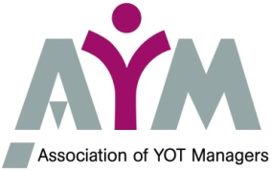
AYM Chair responds to the
YJB draft National Standards 2019

10th December 2018
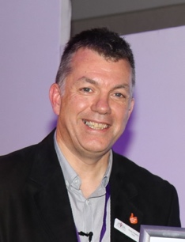

Andy Peaden, Chair of AYM says:
“The draft National Standards raised some concerns for AYM. The focus on function rather than process means that they may be interpreted in differing ways across the country, leading to less consistency.
We need clear standards to ensure that there isn’t justice by geography, and that children remain at the heart of the process, with their voices heard and a joined-up approach across all the services they need to prevent offending.
So, we welcome the ‘child first, offender second’ principle laid out in the Standards. This needs to be firmly embedded into all agencies and government departments involved in the Youth Justice System. We would encourage an approach which creates specific and accountable National Standards for the whole YJS, not just YOTs and local partners.
The accountability of Management Boards and other local partnerships needs more focus than this draft provides, and there are other areas of practice needing more detail or inclusion.
We have been encouraged by our discussions with Charlie Taylor, Colin Allars and Stephanie Roberts-Bibby at the YJ Convention. They joined our Executive meeting and we had a frank and positive discussion about the Standards. We hope that this will assist in strengthening these draft National Standards and in updating the relevant operational guidance, so they support services in ensuring consistent and high-quality practice.
Finally, we would wish to stress the core aim of the YJS, as laid out in the Crime and Disorder Act 1998, which is “to prevent offending by children and young people”. This aim needs to permeate everything included in the draft National Standards.
Notes:
The Association of Youth Offending Team Managers (AYM) is the professional association for Heads of Service (YOT Managers) in Youth Justice, representing the vast majority of Services across England. As such we are a strong voice within and for the youth justice system. See http://aym.org.uk for further information.

